Soybeans in the Natural State
Jordan Sanford
Gurdon High School

In order to meet the scholarship essay requirements, I shadowed Derek Helms who is a soybean farmer here in Arkansas. We spent the day walking around his farm with him showing me the different aspects of farm life, and how he manages a farm. He showed me how they spray and irrigate the crops, taught me about soybeans and their growing process, and his history in the business.

Derek Helms does not only grow soybeans, he is also a dairy, corn, and rice farmer. He received his Bachelors of Science degree in Agricultural Business at Southern Arkansas University in Magnolia and has been in the farming industry since he was a little kid. His family has deep roots in the industry, as they have been farming in the area since 1870 but are a newer to the soybean industry, only beginning in 1968 with their first crop. Derek helms has been farming for a total of 30 years, which the past 10 years he has been farming on his own. He recently acquired a lease of land around Terre Noire Creek where they are now installing a more efficient irrigation system. As of now, they are laying 27,000 feet of piping that when finished will allow them to better irrigate their fields and will also include a reservoir in order to have water no matter water levels. The system he is using now is three pumps that are able to send 22,000 gallons a minute to his farm, the important factor for him of mobbing to a new system is that it would be more efficient to his farm and more beneficial to other farms down the river from him as it would keep water in the river for them to use as well.
After learning the farms background and future plans, we began talking about how his family added soybeans to their farm as they added those one hundred years after their initial start. He explained that they required lower maintenance, they have a shorter growing season (in this area it is about 120 days) than most crops, and were cheaper to produce than other products they farm. Soybeans keep his farm growing as they produce their own nitrogen and then release it into the ground. Other crops, such as corn, need to absorb it from the ground and require nitrogen to grown effectively. Helms said that soybeans are a great addition to their farm as they save money by growing soybeans in one area first, letting them release the nitrogen and then growing a different crop there the next year. This way, he does not need to fertilize the fields with nitrogen although he stills sprays other vitamins and minerals for effective growth. At this time we headed over to his lease on the Terre Noir Creek and he explained in great detail about how he sprays his farm. They mix round up and different herbicides in order to get the best mixture. Helms said this has to be done very carefully throughout the farm because different crops have different needs. Soybeans are classified as broadleaf, so technically you could spray grass killer on it but to get the broadleaf weeds out you have to do it carefully in order to keep the soybeans. However for something like corn (a grass) he can easily spray for broadleaf but has to be careful in order to spray for grass.
Towards the end of the day, he asked me if I had any questions. My main question was why he bought seeds each year instead of using seeds from the previous crop. He explained that it would be a cheaper start up, but in the long run you would eventually start losing money due to advancements in genetic mutation, which he uses to his advantage. Every year there are advancements made to make the crop grow faster and develop more resistant to certain pesticides and pests. Another question I had is that if soybeans have so many advantages compared to other crops; why not invest the entire growing area to them? He responded that the market is always changing and when you plant your crops you have a good idea of what the market will be when they are ready to harvest. If you have your money in multiple crops, you’re covered if one doesn’t do as well or the market isn’t as good as expected. This is why they invest their farm resources in corn, soybeans, rice, and dairy cows.
While we were driving around his farm, heading back to where we began he taught me about his ecological responsibilities as a farmer. He explained that they had to be careful and plan well when they fertilized the fields because if a storm came after fertilization, those chemicals, vitamins, and minerals would get washed into the river. Also, being an ecological farmer means planning for years ahead about his crops which keeps his land fertile and in good shape. Crop rotations are a major point to him, because when you rotate crops you keep from using all of one vitamin or mineral from the soil. It is best to give land a year off to rest and reabsorb those vital nutrients in order to keep producing good crops.
All in all, I had a great day walking around and looking at the different aspects of growing soybeans and farm life in general. Derek Helms explained the whole process from planting seeds to taking the crops to Little Rock to the distribution center. He explained how soybeans are a very beneficial crop in today’s society. This experience really made me open my eyes and look at soybeans. I appreciated the experience of learning about soybean farming while having the opportunity while applying for a scholarship.

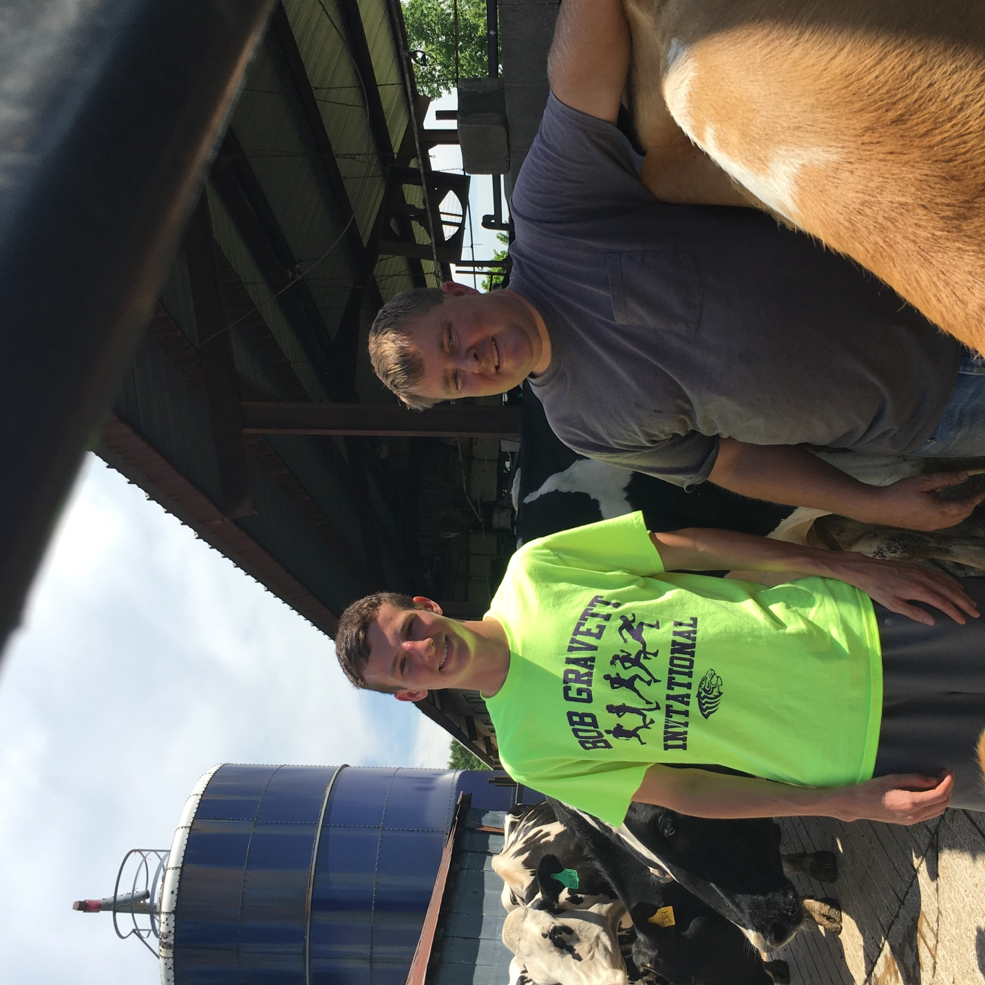
Mr. Helms and I after getting back from the soybean fields at his dairy farm.

